Draftfcb Digital Department
Quality Assurance
A Guide to Writing Great Defects
Created by: Carl Arndt, Lead Quality Assurance Manager

Table of Contents
Table of Contents 1
Summary 2
‘When’ matters with Defects too 2
“I Found a Defect! I think…” 3
Defect Key Points 3
Defect Nice to Have Points 4
Example 5
Summary 5

Summary
After reading this document you will hopefully have a better understanding of what a great defect needs to have to be… great. I can hear it now…

“But Carl, why should I put all this stuff in a defect? This takes too much time!”

Well, I’ll tell you why speedy: The more information that goes into a defect early, the earlier the issue can be triaged and resolved, and the sooner the requirements on the project are met and we’re able to deliver a high-quality product to the client that makes them happy. And we all want happy clients. Happy clients = more money for the company, more money for cultivating new clients, bringing in new business, developing new projects, and hopefully, more money for you.

Great defects = more money. Simple as that.

‘When’ matters with Defects too
Before we get into the details of what makes a defect great, I wanted to discuss timing of the defect for a moment.
“Carl, if defects = money, how much money are these defects costing me/the company?”
I’m glad you asked…

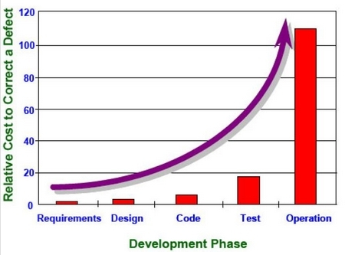

This chart illustrates how the cost of defect increases dramatically over time the later it’s found in the development process. Partial or incomplete defects qualify as well. A defect that doesn’t contain all the relevant information could cause only part of the issue to be fixed and the other portion to get released to the client.

Example: A tester writes a defect on a perceived issue with an earlier browser version that is in scope. The tester writes it up with the one browser, but doesn’t check the other browser versions. The fix gets released into production with a remaining issue on a different browser version. Oops. That just cost more money (and more time – which is money…)

On the flipside – a defect caught in the requirements phase is in theory very inexpensive to correct – even compared to one caught in QA. Money saved = much rejoicing.

“I Found a Defect! I think…”
Before you enter that defect into the issue tracking system, please:
- Investigate the issue – Ensure that the issue is In Scope. Out of scope issues are not productive.
- Ensure that it isn’t logged already – Before typing away, check the current issue list and make sure it isn’t already entered. Duplicate defects aren’t that useful and if any do get entered, proper protocol indicates that the defect with the higher defect id (the later one) is closed as a duplicate.
- “Wait – I see two issues there. I’ll write them together in one defect.” STOP right there. Defects have to be autonomous. One issue per Ticket. Repeat after me… One issue per ticket. No lists of issues in one ticket. When there is only one issue per ticket, the process of fixing them and closing them is a lot smoother and can be tracked correctly. If there is a list of five things in one defect and the developer can fix two of them, two are out of scope, and one is a duplicate, what status are we giving that defect?
- Ideas are not bugs – Not everything is a defect. Some of these ideas should be logged as a Feature Request, a task, a sub-task, or other issue type.

So you’re pretty confident that the issue is in scope, not already logged, and it’s an issue by itself… Good. Keep reading…

Defect Key Points
In my opinion – and the opinion of many other quality professionals – these are the minimum elements of a defect.
- Summary / Title – The summary / title says in a sentence or less what the problem is. Including a few details in the summary is helpful too, for example, including the build number or browser/OS version.
  - Example: “Win7 / IE8 – Parts Page – The ‘view more parts’ link is broken”
  - Do: Be concise, include versions, brief details
  - Don’t: Make the summary/title a paragraph long
  - Don’t make the summary/title of the defect be: “Link broken.” Ugh.
- Description – Write a description of the issue here. Steps to replicate can be entered here, as well as environment information, whether you can replicate the issue (and how many times you replicated it), other note-worthy information (example: The issue is only happening on IE9 Win7 but not IE8.)
- Expected Result – Enter what exactly you were expecting to happen when you execute the steps. Sometimes expectations are off and the system is acting as it should.
- Actual Result – Enter what happened at the end of the steps. This is the thing you observed to be wrong so be detailed about what happened.
- Screenshot – Include a screenshot for almost all defects. A picture is worth 1,000 words, and a screenshot included in a defect is no exception.
- Steps to reproduce – After writing the steps, go through them again. It will uncover any missteps or extra details that need to be included in the bug and it’s always good to be able to say you can reproduce the issue.
- Browsers / Platforms – Be sure to enter the Browser version and which platform you saw the issue. If you do see an issue on one browser, attempt the replicate the issue on different browsers to see if it’s browser specific or a global issue.
- Test Data – Include the data you were using when you found the bug. Logged on as a specific test user? Include id/pass. Error message displaying when you open a certain file? Include the name of the file.
- Error Messages – Enter the wording of the error message into the defect if you have one. Don’t just say ‘error message displayed’.
- URL – Include the url of the page where the issue presented itself in the description field of the defect

Ok nice, you have entered the key points. Now add the following too if you can…

Defect Nice to Have Points
In my opinion – and the opinion of many other quality professionals – these points are helpful to have included in a defect.

- Priority / Severity – If the defect is entered by QA, this is often an educated guess on how severe or how high of a priority the issue is. Depending on software development workflow, this can be changed up or down by stakeholders of the project.
- Video file – Sometimes defects that are difficult to reproduce or have more than 10 – 15 steps need a replay of the reproduction of the defect.
- Preconditions – Describe relevant details on the state of the system before the defect presented itself. Do certain dates have to be set? Does the system need certain configurations turned on?
- Logs – if the relevant lines in the log are few, include it in the description, otherwise include them to the defect as an attachment
- Reproducible or not? – Include this, and also mention if the defect is difficult to reproduce too.
- Enter/Investigate the issue now – not at the end of the day. It’s important to enter the issue you found earlier rather than later. Maybe the issue you found, if fixed early, can prevent other costly issues to occur. Proper reporting of test progress is more transparent when defects are entered quickly as well.

Example
Here is an example of a well written defect.
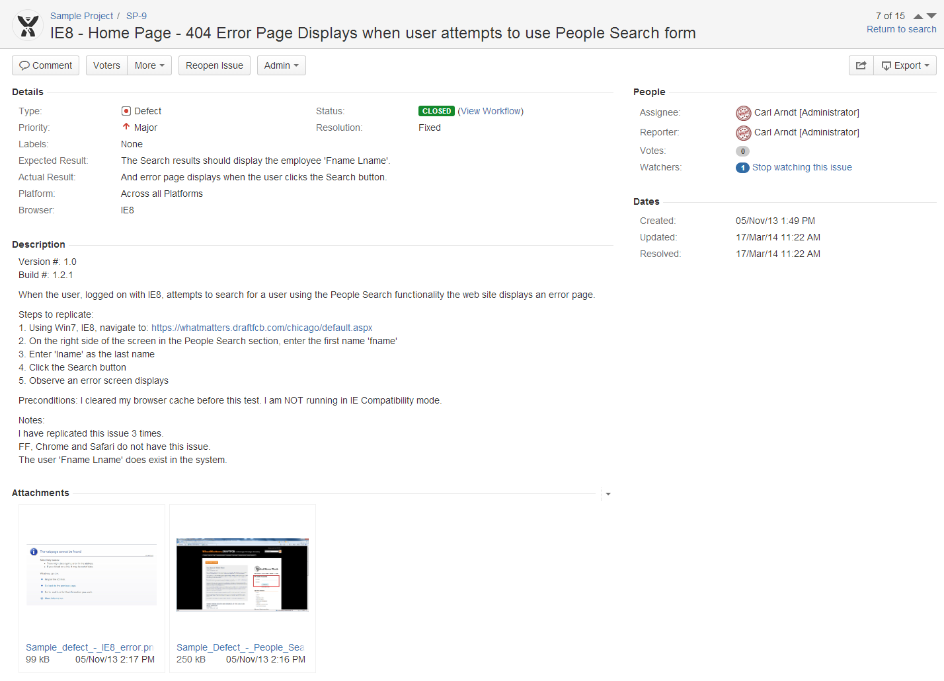

Summary
If you follow the key points of defect writing you will greatly increase the chance that your project will have less issues, less high priority/severity issues, and thus you will increase your chances of delivering high quality projects that make you clients, bosses, and yourself happier.

Thank you for taking the time to read this guide. Now go write great defects.

Happy Hunting!

